Name___________________________________. Mark= /

HUMAN BIOLOGICAL SCIENCE. YEAR 12. 2012.

Primates and Hominin test.

|  |  |  |
| --- | --- | --- |
| Test section | Possible mark | Your mark |
| Multiple choice | 10 |  |
| Short answer | 34 |  |
| Extended answer | 10 |  |
| Total | 54 |  |

***Multiple choice answer sheet.* Use a ball point or ink pen to mark an X** on the letter that represents the best answer from the choice of answers . Marks are not deducted for wrong answers.

|  |  |
| --- | --- |
| Question | Answer |
| 1 | A B C D |
| 2 | A B C D |
| 3 | A B C D |
| 4 | A B C D |
| 5 | A B C D |
| 6 | A B C D |
| 7 | A B C D |
| 8 | A B C D |
| 9 | A B C D |
| 10 | A B C D |

Multiple Choice Section

1. Which of the following would contain the greatest number of species?
2. Kingdom
3. Phylum
4. Species
5. Genus

Look at the three skulls below. Use these drawing to answer questions 2, 3 and 4.

|  |  |  |
| --- | --- | --- |
| Skull | | |
| A | B | C |
| http://3.bp.blogspot.com/_vZtAOUAS7HQ/SDD6C3TtgHI/AAAAAAAAAIc/b-16E1IpaCk/s400/skull_study_profile-400.png | http://www.transientvisions.com/images/gorilla_skull.jpg | http://4.bp.blogspot.com/_prb792zvLfg/S7qyhS7Gt0I/AAAAAAAAAtg/QUdz7-X3dlU/s1600/Australopithecus.jpg |

1. Which skull shows most Prognation?
2. A
3. B
4. C
5. None of the skulls show Prognation.
6. Which skull has a diastema?
7. A and B
8. B only
9. A only
10. C only
11. Which skull/s are not hominin?
12. A
13. B
14. C
15. A and C
16. Which of the following matches the correct Hominin with the correct tool culture?
17. Oldowan and Homo sapiens
18. Oldowan and Homo erectus
19. Acheulian and Homo erectus
20. Acheulian and Australopithecus.
21. Which of the following statements about the move to an agricultural lifestyle by Humans is **FALSE**?
22. Its long term affect was an increase in population numbers.
23. It caused people to move from hunter gathering lifestyles.
24. It is first seen with Homo erectus.
25. It is not seen in all parts of the world.
26. Which of the following lists the primates in order of evolution, going from simple to more complex.
27. Lemur, monkeys, apes and Humans.
28. New world monkeys, Old world monkeys and apes.
29. Old world monkeys, new world monkeys and lemurs.
30. Apes, Prosimians, monkeys and Humans.
31. Which of the following will have the largest olfactory center relative to total brain size?
32. New world Monkey
33. Old world Monkey
34. Homo erectus
35. Lemur
36. Which of the following is **not** true of Homo erectus?
37. It had a sloping forehead compared to Homo sapiens.
38. It was able to live in colder climates than Homo habilis.
39. It had a similar cranial capacity to Homo neanderthalsus.
40. It had pentadactyl hands.
41. Which one of the following changes is irrelevant in the evolution of humans?
42. An increase in convolutions of the cerebral cortex.
43. Precision grip.
44. Increased complexity of tool culture.
45. A move from grain to root vegetables in the diet.

Short Answer Section

1. Write definitions for all of the words in the table below

(3 marks)

|  |  |
| --- | --- |
| Term | Meaning |
| Arboreal |  |
| Bipedal |  |
| Pentadactyl |  |

1. The sifaka and the Aye aye are both primates. What does this tell you about them?

(5 marks)

___________________________________________________________________________________________________________________________________________________________________________________________________________________________________________________________________________________________________________________________________________________________________________________________________________________________________________________________________________________

1. A skull is found at an archeological dig site. It looks like it may be Homo erectus or Homo sapein. The scientist takes an endocast of the skull. What is an endocast and what is the indicator he/she is looking for to help show which type of skull it is?

(3 marks)

____________________________________________________________________________________________________________________________________________________________________________________________________________________________________________________________________________________________________________________________________________________________________________________________________________________________________________________________________________________

1. The use of fire caused major changes in lifestyle for hominins.
2. Which Hominin first used fire?

___________________________________________________________________________

(1 mark)

1. What were the impacts of the use of fire?

_________________________________________________________________________________________________________________________________________________________________________________________________________________________________________________________________________________________________________________________________________________________________________________________________________________________________________________________________

1. marks)
2. What are the advantages of forward facing eyes?

__________________________________________________________________________________________________________________________________________________________________________________________________________________________________________

(3 mark)

1. Why do new world monkeys and Humans have a very mobile ball and socket joint in their shoulder?

(1 mark)

__________________________________________________________________________________________________________________________________________________________________________________________________________________________________________

1. List 4 evolutionary trends seen in the Hominin group.

(4 marks)

____________________________________________________________________________________________________________________________________________________________________________________________________________________________________________________________________________________________________________________________________________________________________________________________________________________________________________________________________________________

1. Look at the tool below.

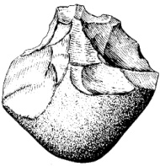

What is type of tool culture is this an example of? Give a reason for your choice.

_________________________________________________________________________________________________________________________________________________________________________________________________________________________________

(2 marks)

1. About 12,000 years ago the Agricultural/Neolithic revolution started to take place. It was thought to be in part due to changes in the Earth’s climate.
2. What is meant by the Agricultural/Neolithic revolution?

________________________________________________________________________________________________________________________________________________________________________________________________________________________________

(2 marks)

1. What where some of the long term impacts on Humans as a result of this revolution?

_____________________________________________________________________________________________________________________________________________________________________________________________________________________________________________________________________________________________________________________________________________________________________________________________________________________________________________________________________________________________________________________________________________

(4 marks)

1. What type of stone tool is shown below? Give a reason for your choice.

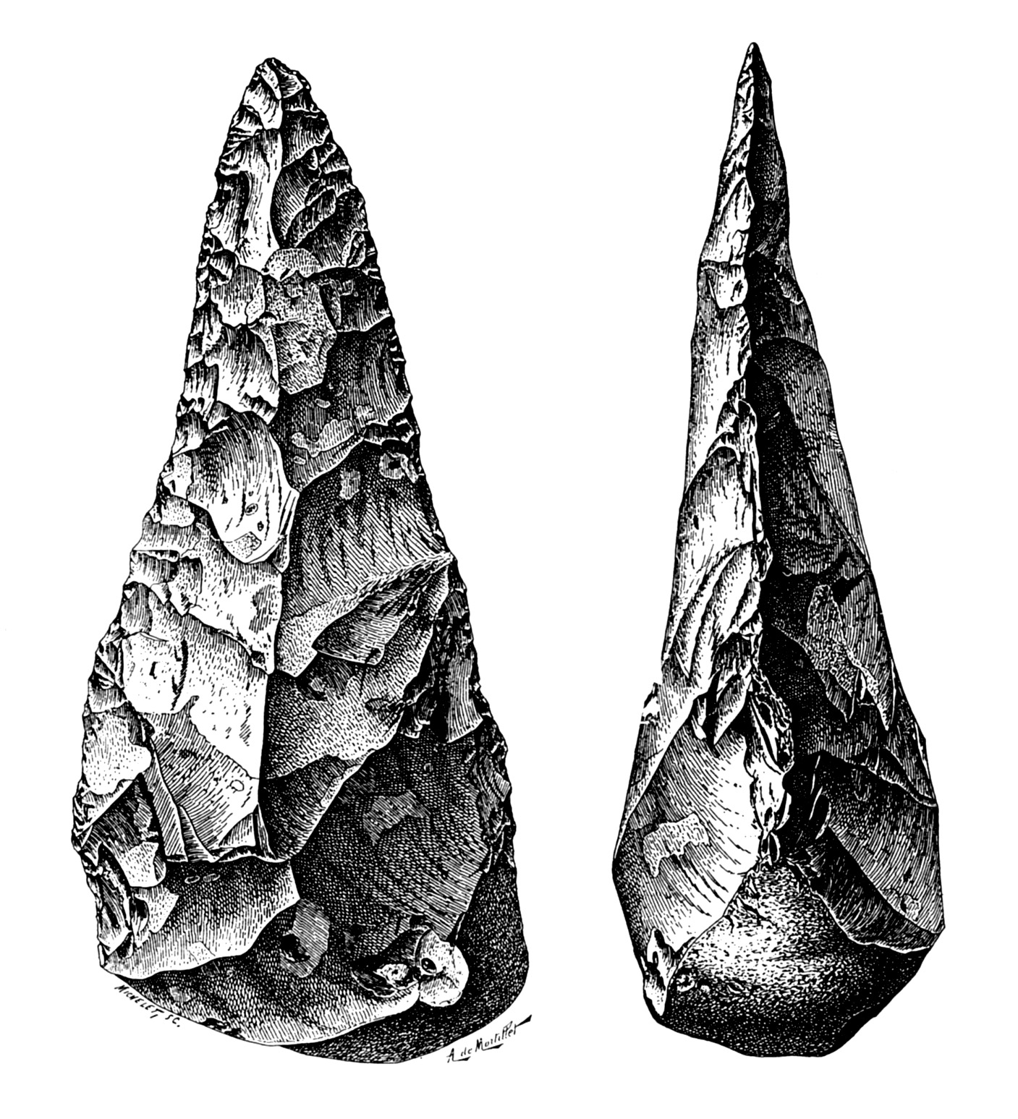

________________________________________________________________________________________________________

(2 marks)

Extended Answer Questions

1. Lucy was the skeleton of an Australopithecus found in Africa. She was obviously a Hominin, but not a Homo sapien. Give the characteristics that would have made her a Hominin. Also list the characteristics that separated her from the Homo sapiens.

(10 marks)

_____________________________________________________________________________________________________________________________________________________________________________________________________________________________________________________________________________________________________________________________________________________________________________________________________________________________________________________________________________________________________________________________________________

_____________________________________________________________________________________________________________________________________________________________________________________________________________________________________________________________________________________________________________________________________________________________________________________________________________________________________________________________________________________________________________________________________________

_____________________________________________________________________________________________________________________________________________________________________________________________________________________________________________________________________________________________________________________________________________________________________________________________________________________________________________________________________________________________________________________________________________

_____________________________________________________________________________________________________________________________________________________________________________________________________________________________________________________________________________________________________________________________________________________________________________________________________________________________________________________________________________________________________________________________________________

_____________________________________________________________________________________________________________________________________________________________________________________________________________________________________________________________________________________________________________________________________________________________________________________________________________________________________________________________________________________________________________________________________________

**THE END**